Return to the Workplace

User Manual

Environment and Climate Change Canada is committed to ensuring that the health and safety of every employee is protected while they are at work. This app was developed in response to the COVID-19 pandemic to support a safe, organized and gradual return to ECCC workplaces. The app allows employees to request access to ECCC workplace sites and managers to monitor, review and approve employee requests.

Contents

Accessing the app 3

• **Desktop, laptop or tablet access** 4

• **Mobile device access** 4

Submitting a request to work onsite 6

• **Submit a request** 6

• **Step 1 – Fill in your request details** 8

• **Add visitors to your request** 8

• **Step 2 – Select a date** 11

• **Step 3 – Select a timeslot** 11

• **Step 4 – Select your manager** 13

• **Step 5 – Employee attestation** 13

• **Verify the status of your request** 14

• **Cancel your request** 14

Submitting a request to pick up equipment from the work onsite 15

• **Submit a request** 15

• **Step 1 – Fill in your request details** 17

• **Step 1b – Requesting help to remove the equipment** 17

• **Step 2 – Select equipment** 18

• **Step 3 – Select a date** 18

• **Step 3 – Select a timeslot** 19

• **Step 4 – Select your DG** 20

• **Step 5 – Employee attestation** 20

• **Verify the status of your request** 21

• **Cancel your request** 23

Approving a request to work on site 24

Approving a request for picking up equipment 26

Booking Assistant 28

**Submitting requests as a booking assistant** 28

Contact Us 29

Privacy Act Statement 30

COVID-19 Health & Safety Measures 30

Helpful links 34

# Accessing the app

The Return to the Workplace App is available through Microsoft **Power Apps**.

To access the app, you have two choices:

* **Desktop, laptop or tablet**: Microsoft Access Power Apps using a web browser (see p. 2)
* **Mobile device**: Download Microsoft Power Apps directly to your device. (see pp. 2-4)

Try It:

* **Desktop, laptop or tablet access**
  + If you prefer to launch the app through your desktop/laptop/tablet web browser, simply click this link: [https://apps.powerapps.com/play/18724d6f-1497-4569-b840-feb8423f2db9?tenantId=740c5fd3-6e8b-4176-9cc9-454dbe4e62c4](https://apps.powerapps.com/play/18724d6f-1497-4569-b840-feb8423f2db9?tenantId=740c5fd3-6e8b-4176-9cc9-454dbe4e62c4&source=portal&screenColor=rgba(0%2C%20138%2C%200%2C%201))
  + You will then be asked to sign into your **ECCC Office 365 account** (the same account used to access Microsoft Teams – typically [*FirstName.LastName*@ec.gc.ca](mailto:FirstName.LastName@ec.gc.ca)).

***Note: Please use Microsoft Edge, Firefox, or Chrome. IE is not supported.***

* **Mobile device access**
  + iPhone:Using your corporate or personal mobile device, download **Power Apps** through the App Store.

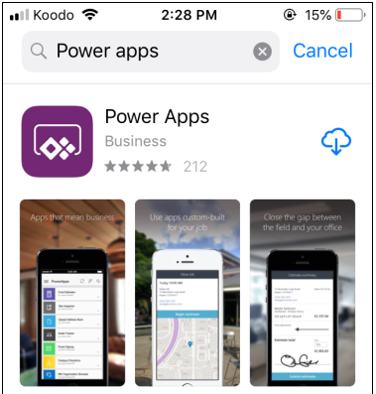

* + Android:Using your corporate or personal mobile device, download **Power Apps** through the Play Store.

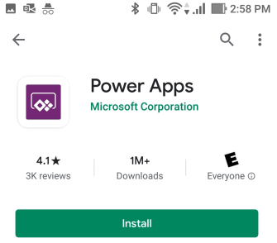

* + Open the app and sign in to your **ECCC Office 365 account** (the same account used to access MS Teams – typically [*FirstName.LastName*@ec.gc.ca](mailto:FirstName.LastName@ec.gc.ca)).

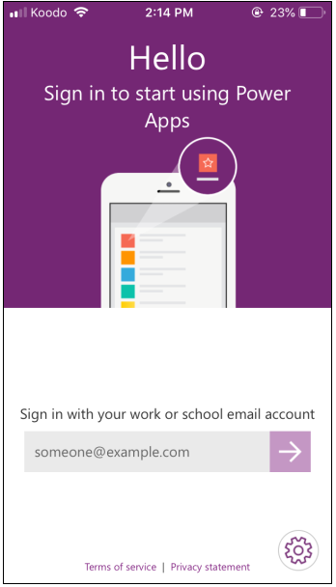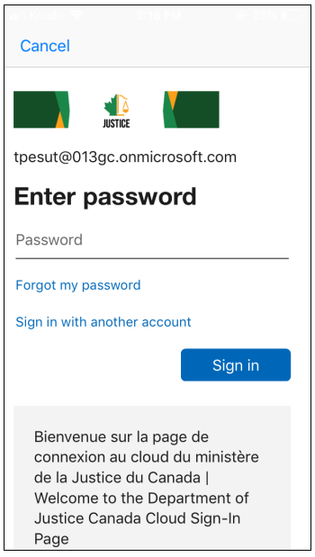

* + Click on “Go to All Apps” to find the **Return to the Workplace.**

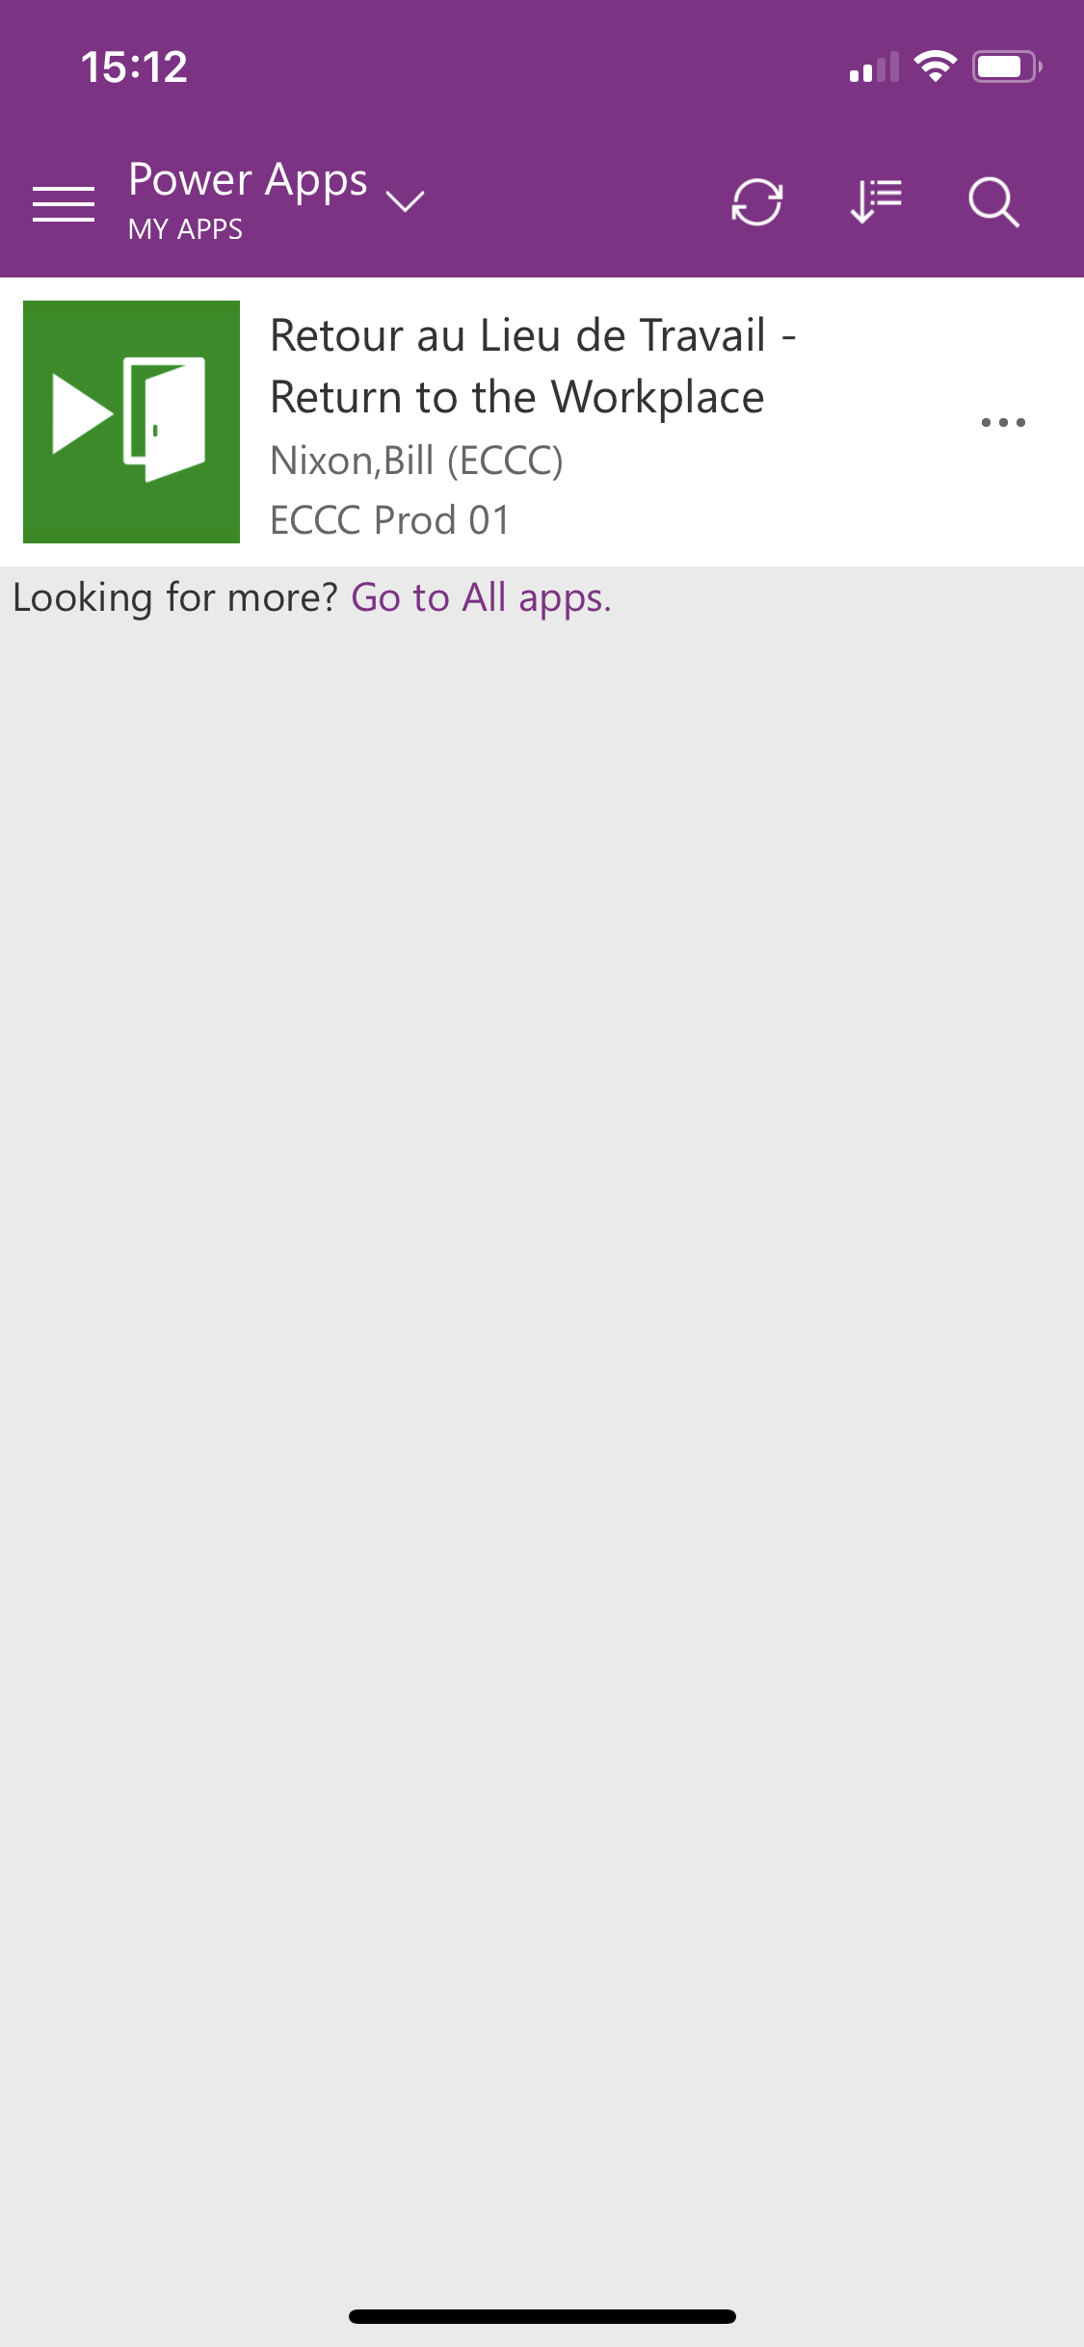

* + Click on the app to launch it.

When you first launch **Power Apps**, you will be prompted by a window where you need to accept the conditions. Use your **ECCC Office 365 account** credentials to sign in to each of them – typically [*FirstName.LastName*@ec.gc.ca](mailto:FirstName.LastName@ec.gc.ca).

Once the four applications are connected, you will be able to click on **Allow**.

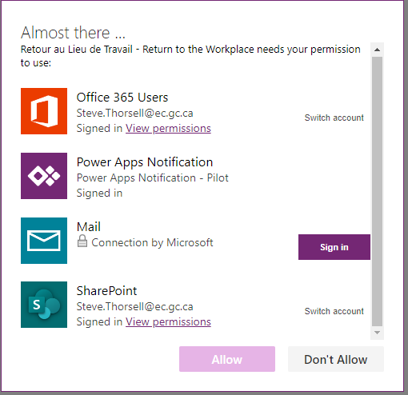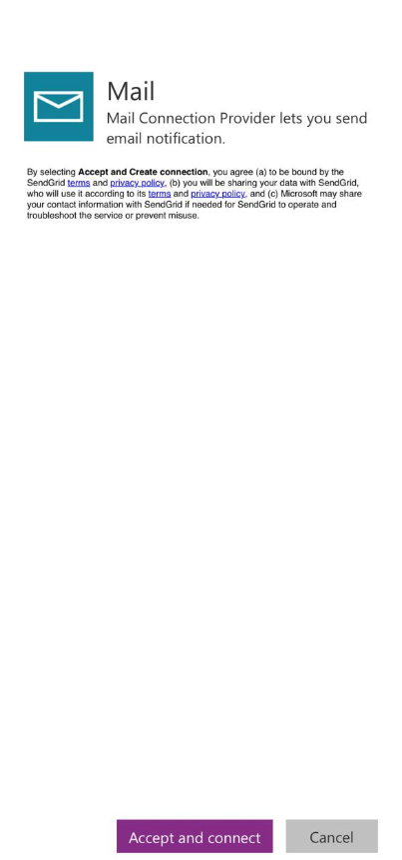

# Submitting a request to work onsite

You can submit requests to access specific areas of ECCC worksites. You must answer a series of questions before the request is completed and is sent to the manager for approval. [A video is also available for this topic.](https://ecollab.ncr.int.ec.gc.ca/theme/media/_layouts/15/Lightbox.aspx?url=https%3A%2F%2Fecollab.ncr.int.ec.gc.ca%2Ftheme%2Fmedia%2FVideoLibrary%2FCreateRequest_HD.MP4)

Try It:

* **Submit a request**
  + Upon initial use of the app, you will be presented with the ***Privacy Act Statement*** and the ***COVID-19 Health & Safety Measures***. You must read through and agree to these pages in order to continue. This content can be viewed again at any time through the app’s menu page.

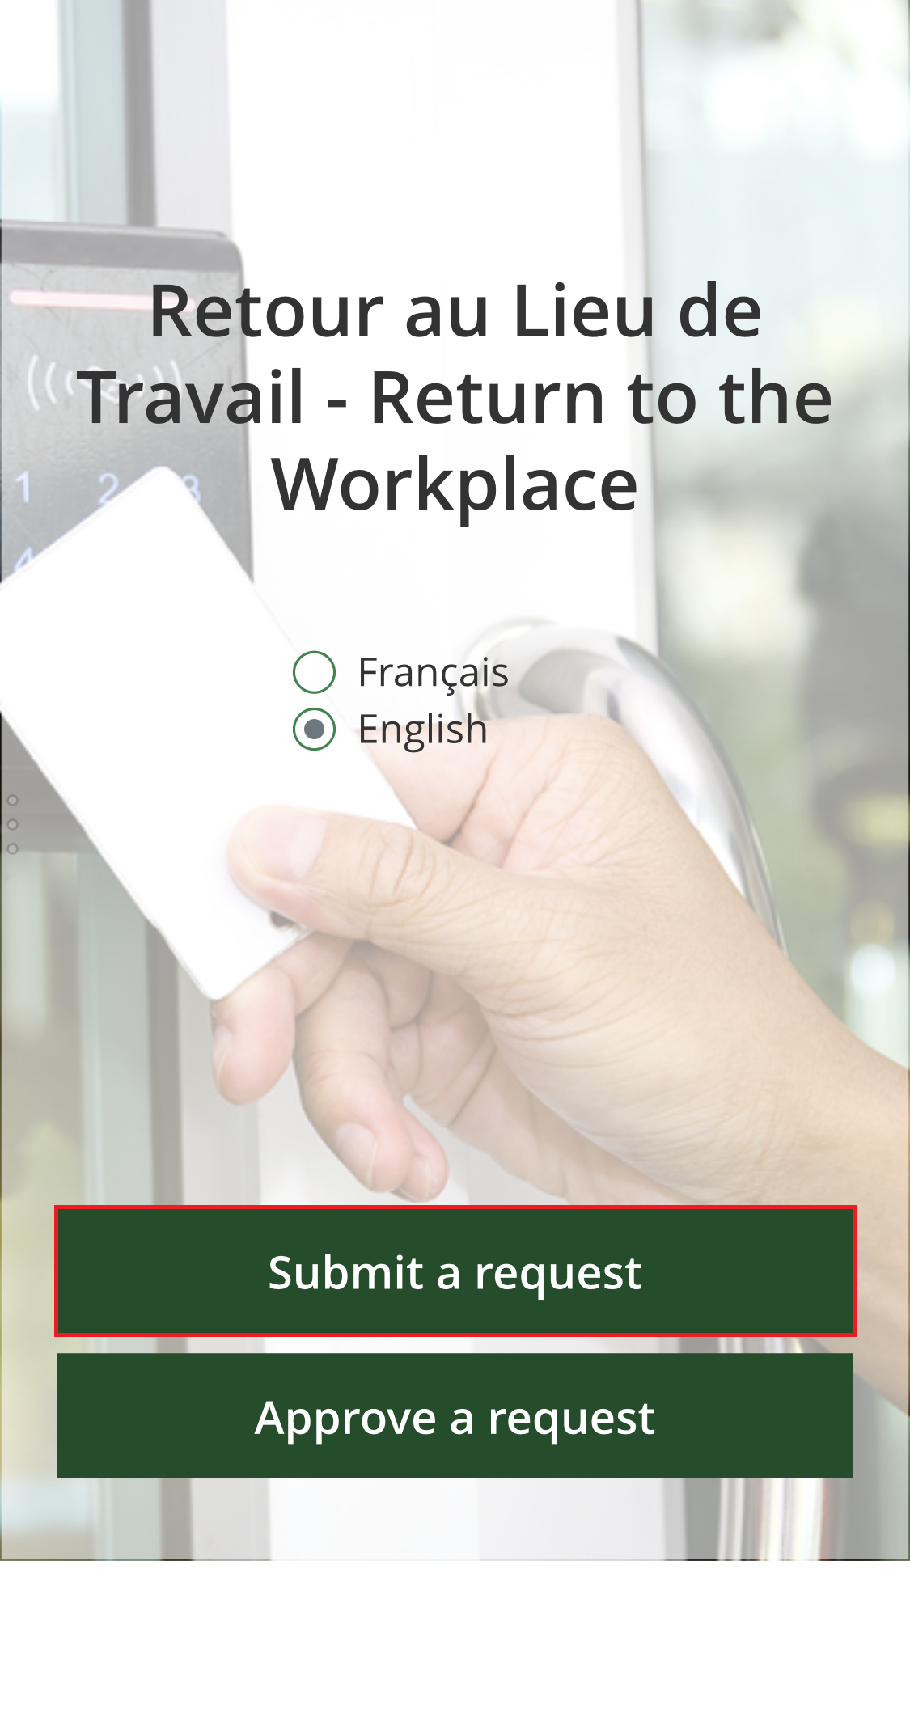

* + From the **Home page,** select “**My Requests”**.

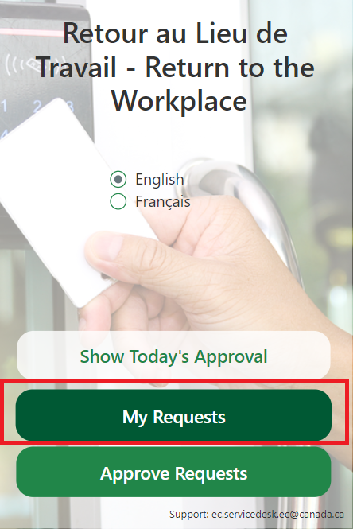

* + The **“My Requests”** view will appear. To submit a new request, click the “**New Request”** button on the bottom of the screen.

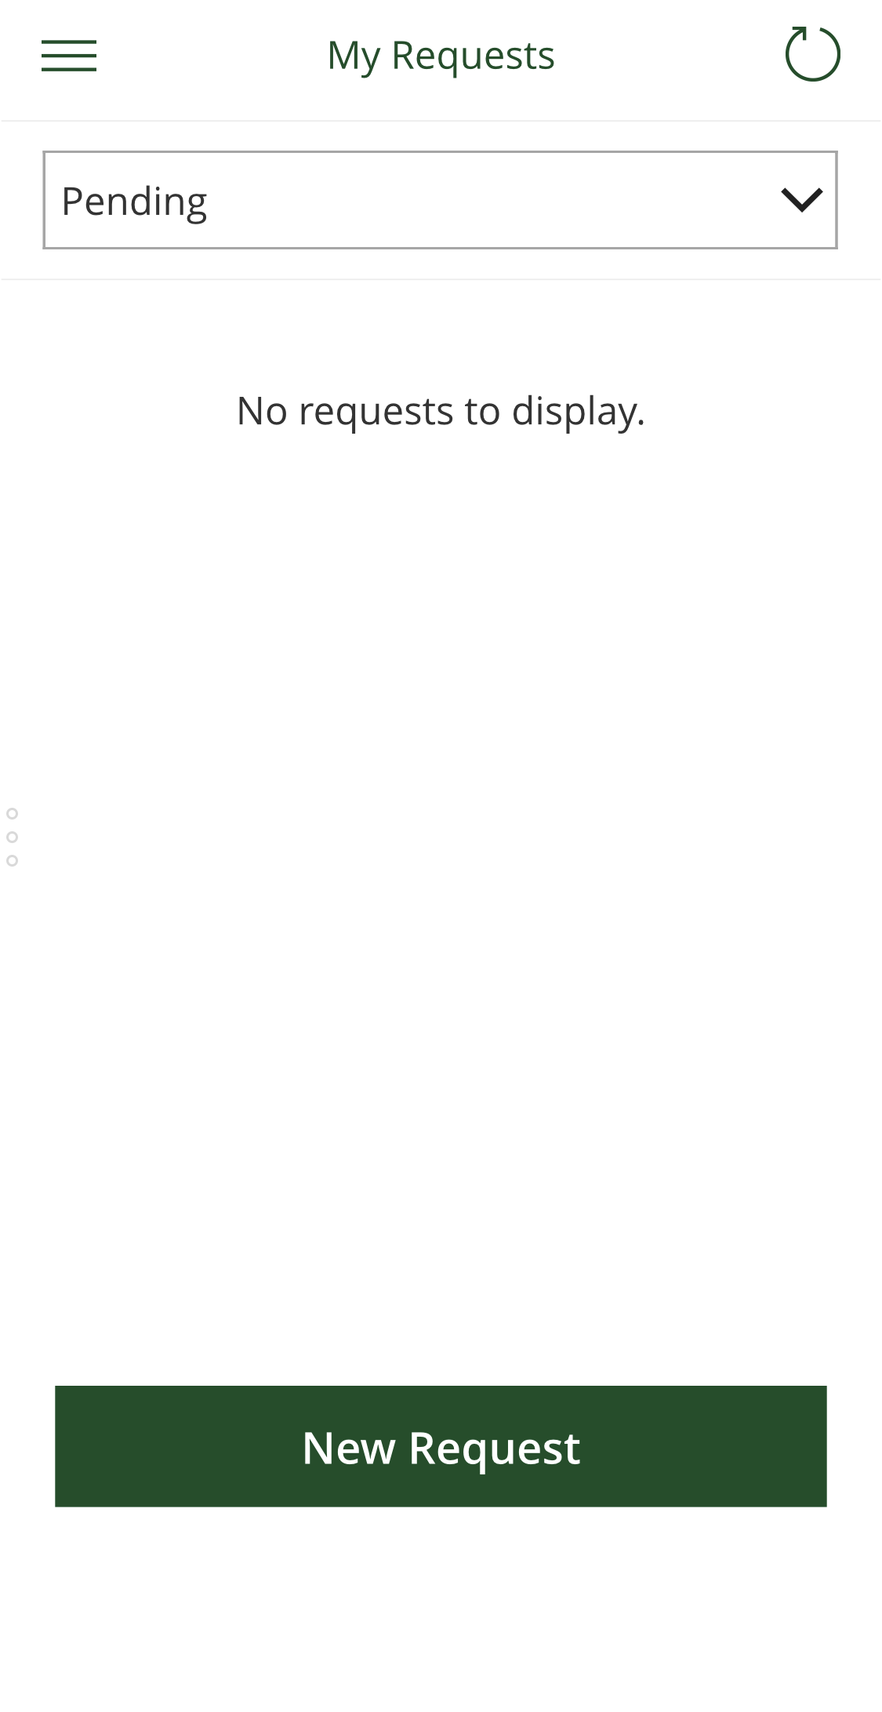

* **Step 1 – Fill in your request details**

You’ll first be asked to select the specific ECCC site you’d like to access, the reason for your request, and whether you need to register any visitors. Please note that if you wish to access more than one floor, you will need to complete a separate request. Click the ‘**Next’** button to continue to Step 2.

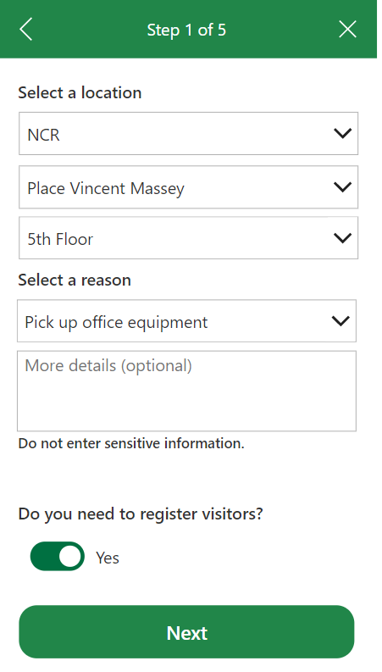

* **Add visitors to your request**

If you indicated that you need to register visitors in Step 1, you will be asked to provide further information before continuing.

* + First, you will be presented with text explaining the process for visitors. Please read the text and click “**Next**” when ready. You will then be asked to provide the contact information for your visitor(s). Click “**Add**” for each new visitor.

Note: Only add the extra visitors (Not yourself)

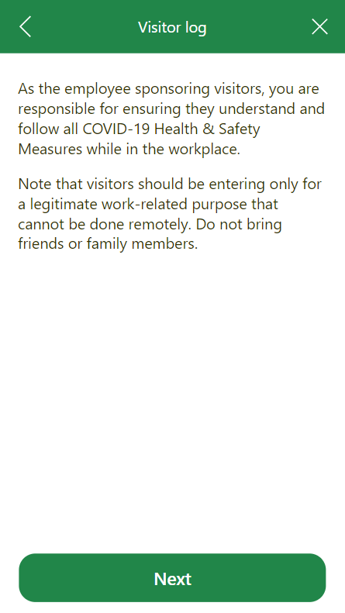

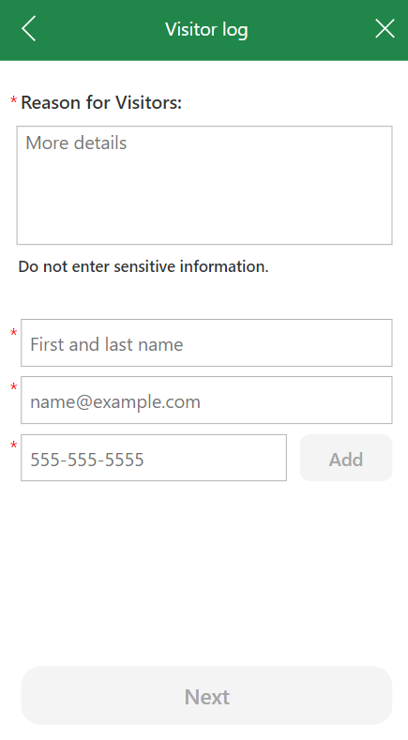

**Please note:**

* + 24 hrs prior to your visitor entering the work place you must complete the attestation for them indicating that they will comply with the *COVID-19 Health & Safety Measures* within 24 hours of entering the office.
  + each visitor must bring a valid piece of government ID in order to collect their visitor badge. Keep in mind that visitors must be escorted by their employee sponsor at all times.

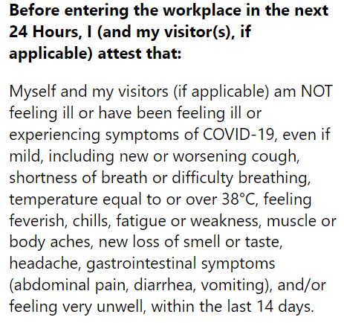

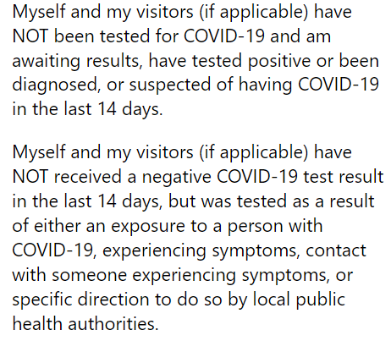

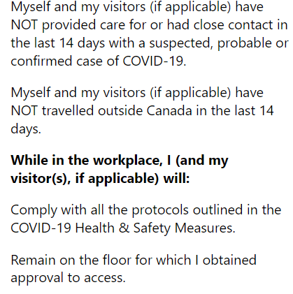

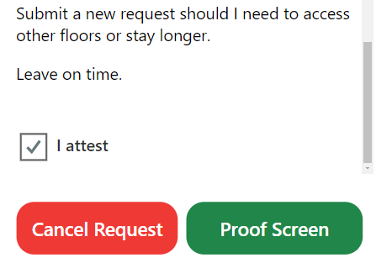

* **Step 2 – Select a date**

Select the date(s) you would like to enter the selected workplace. The selected dates will appear with a yellow border. Click the “**Next**” button to continue to Step 3. Select as many dates as required up to 14 days in advance.

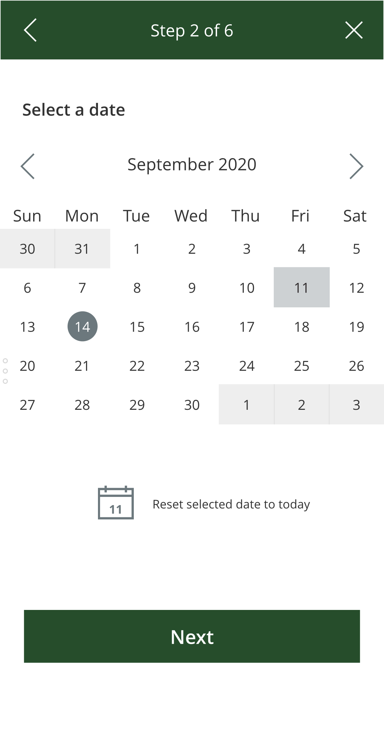

* **Step 3 – Select a timeslot**

**Use the drop-down menus to select a timeslot.** To help you make your selection, the chart will update itself to indicate how many spots are available per hour based on the maximum capacity for the selected worksite. If your selected timeslot is at “max capacity”, you must modify your selection in order to continue. Click “**Next**” to continue to Step 4.

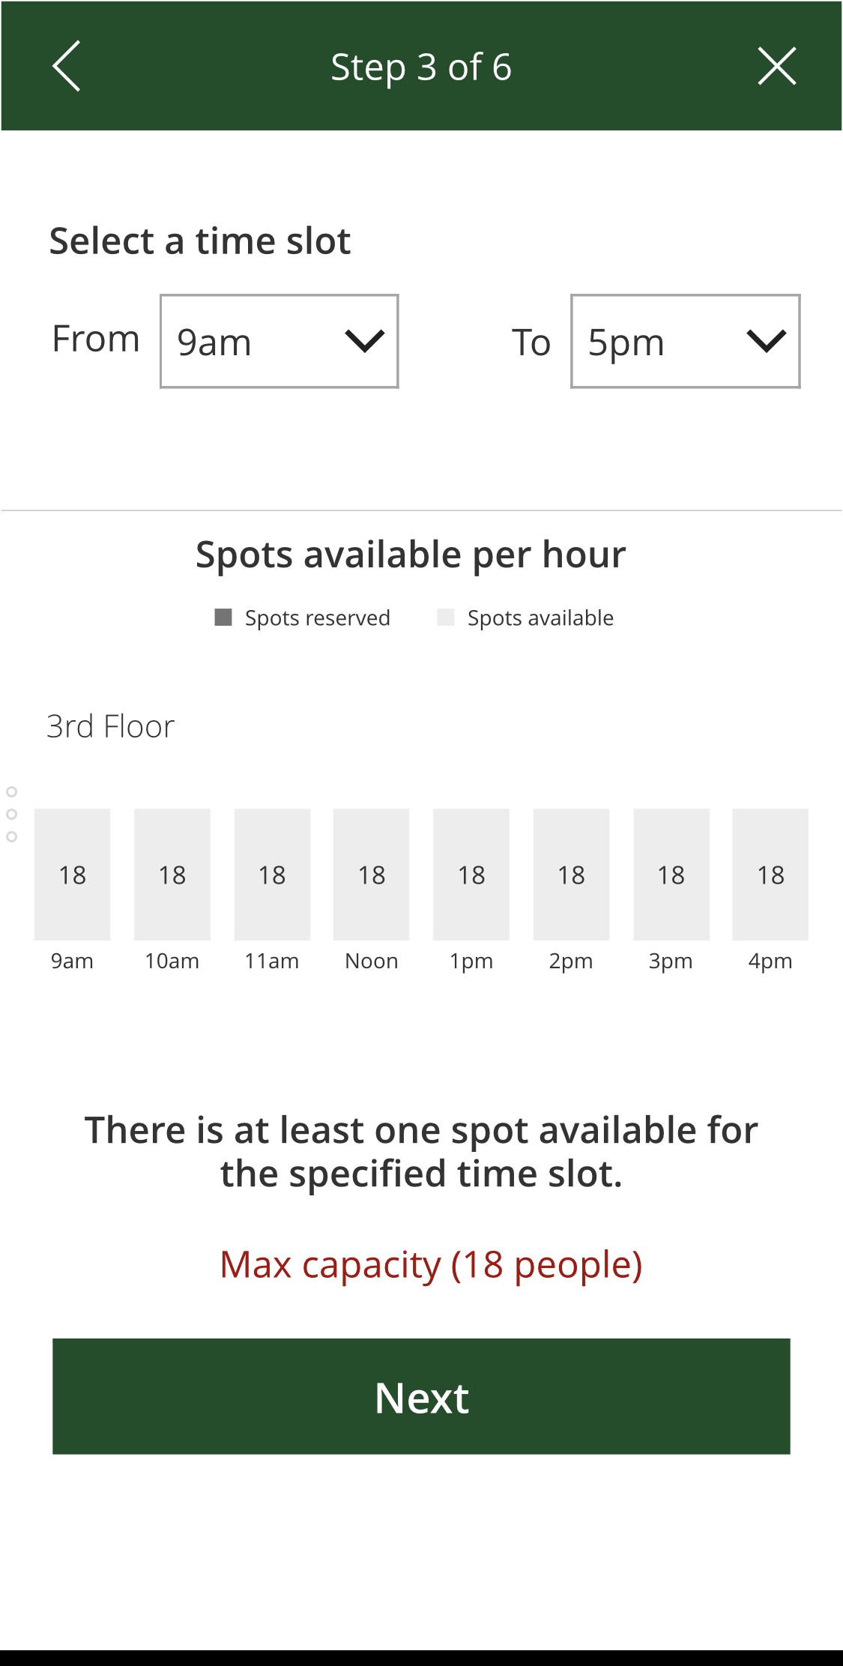

* + Note that if you selected multiple dates for your request, you will instead be presented with a list of your selected dates. A green checkmark next to the date indicates that there are spots available for the selected date/time. A red X indicates that there are no available spots and that you must modify your selection in order to continue. Click on a selected date to view the hourly capacity view per day.

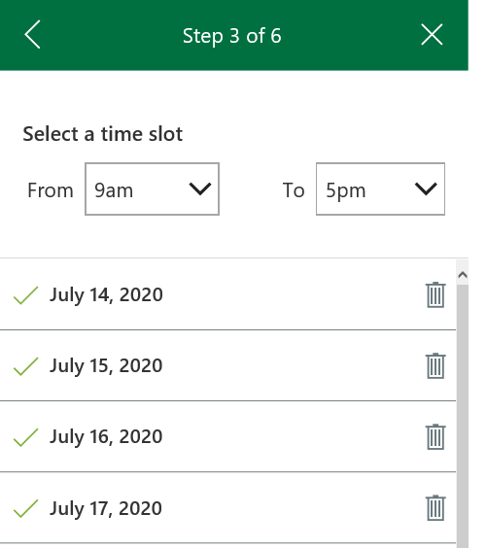 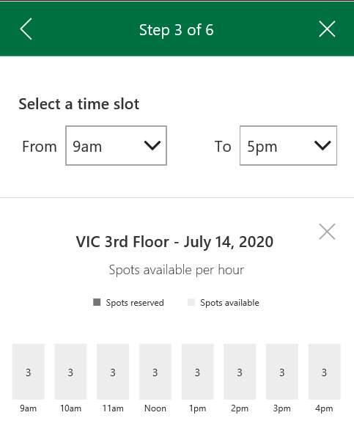

* **Step 4 – Select your manager**

Use the search box to find the manager who will be reviewing your request for approval. Click on the manager’s name to continue. ***Note***If you do not have an option to select a manager, this means that you are on the bypass for mission critical work.

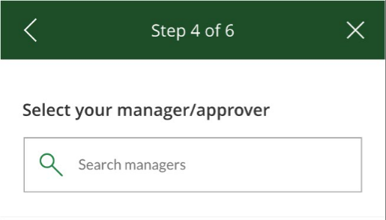

* **Step 5 – Employee attestation**

You will be asked to read and agree to the workplace eligibility conditions for yourself and any visitors in order to complete your request.

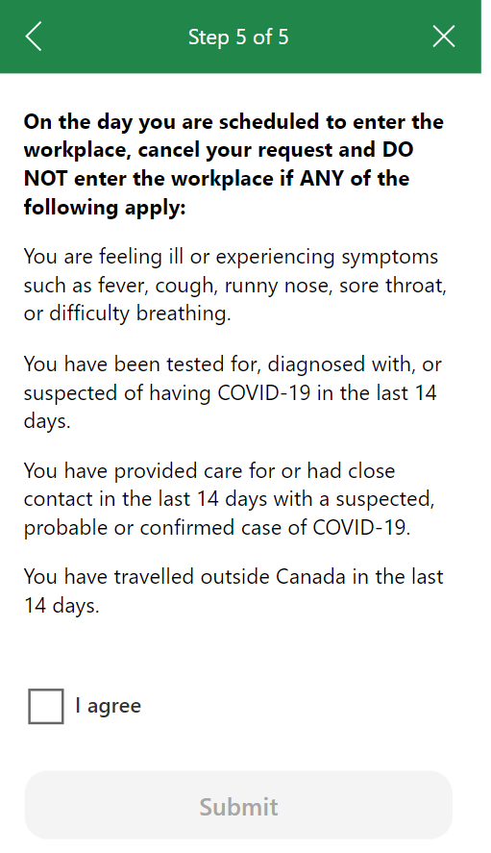

* **Your request has been submitted**: Once the request has been submitted, you will receive an email confirmation with your request details. Your manager will also receive an email notice saying that your request is ready for review.

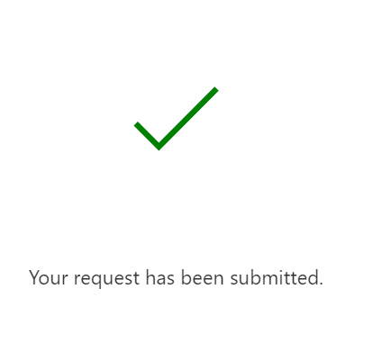

* **Verify the status of your request**

Once your request has been submitted, you will be taken back to the “**My Requests”** screen where you can view the status of your requests. Use the “**Status**” drop-down to toggle between Pending, Approved, Declined, Cancelled, or Finished to view your selected requests.

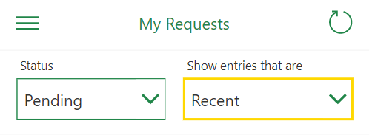

* **Cancel your request**

If you need to cancel your request, select it from the “**My Requests”** screen and click “**Cancel**.” Once your request is cancelled, it will appear under the “Cancelled” section of the “**My Requests”** screen.

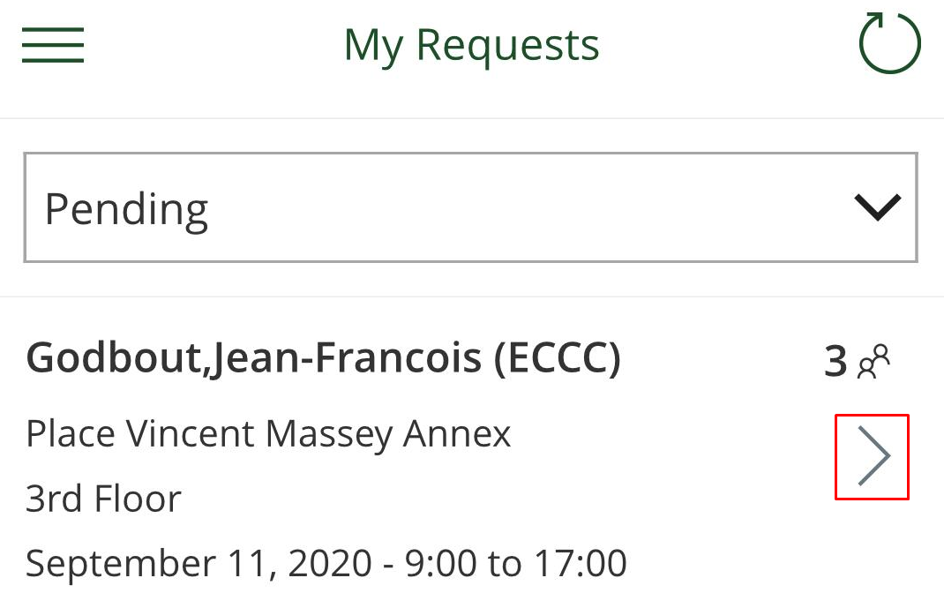

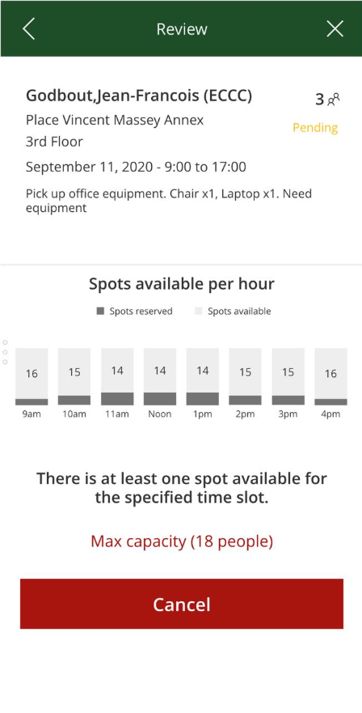

# Submitting a request to pick up equipment from the work onsite

If you need to go into the office to pick up equipment you need to submit a request to your DG through the RTW application. You must answer a series of questions before the request is completed and is sent to the DG for approval. The equipment pick up is very similar to the request to go to work. [A video is also available for this topic](https://ecollab.ncr.int.ec.gc.ca/theme/media/_layouts/15/Lightbox.aspx?url=https%3A%2F%2Fecollab.ncr.int.ec.gc.ca%2Ftheme%2Fmedia%2FVideoLibrary%2FEquipmentPickup_HD.MP4).

Try It:

* **Submit a request**
  + Upon initial use of the app, you will be presented with the ***Privacy Act Statement*** and the ***COVID-19 Health & Safety Measures***. You must read through and agree to these pages in order to continue. This content can be viewed again at any time through the app’s menu page.



* + From the **Home page,** select “**My Requests”**.



* + The **“My Requests”** view will appear. To submit a new request, click the “**New Request”** button on the bottom of the screen.



* **Step 1 – Fill in your request details**

You’ll first be asked to select the specific ECCC site you’d like to access, the reason for your request (select pick up equipment), and whether you need to register any visitors. Please note that if you wish to access more than one floor, you will need to complete a separate request. Click the ‘**Next’** button to continue to Step 2.



* **Step 1b – Requesting help to remove the equipment**

If you need help removing the equipment from the building please click on the appropriate regional link and send an email request specifying what you need, what date and time you would like help. **Please provide them with at least 7 business days’ notice**. This date and time have to match with the date and time you will chose in the upcoming calendar on step 2.

# 

* **Step 2 – Select equipment**

Select the equipment you would like to pick up. Click the “**Next**” button to continue to Step 3.

* 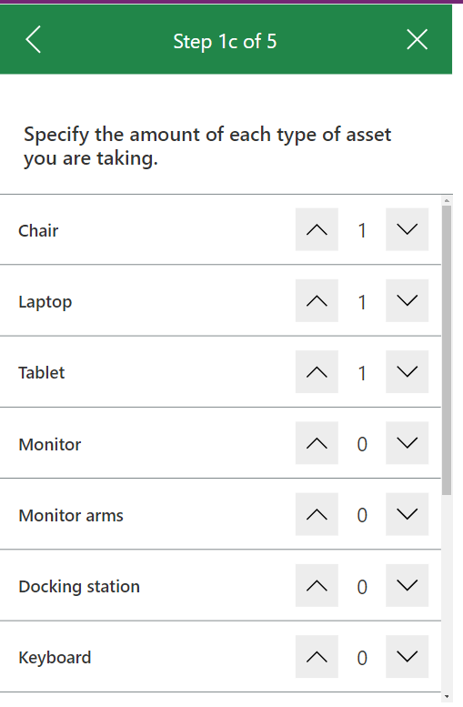
* **Step 3 – Select a date**

Select the date you would like to enter the selected workplace to pick up your equipment remembering the date and time you asked for help, if applicable. The selected dates will appear with a yellow border. Click the “**Next**” button to continue to Step 3.



* **Step 3 – Select a timeslot**

**Use the drop-down menus to select a timeslot (remembering the appointment time you asked accessibility to help you remove the equipment, if applicable).** To help you make your selection, the chart will update itself to indicate how many spots are available per hour based on the maximum capacity for the selected worksite. If your selected timeslot is at “max capacity”, you must modify your selection in order to continue. Click “**Next**” to continue to Step 4.



* **Step 4 – Select your DG**

Equipment pick up MUST be approved by the DG. Use the search box to find the DG who will be reviewing your request for approval. Click on the DG’s name to continue. ***Note***If you do not have an option to select a DG, this means that you are on the bypass for mission critical work.

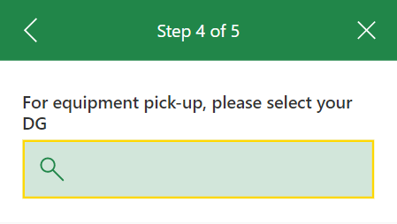

* **Step 5 – Employee attestation**

You will be asked to read and agree to the workplace eligibility conditions in order to complete your request.

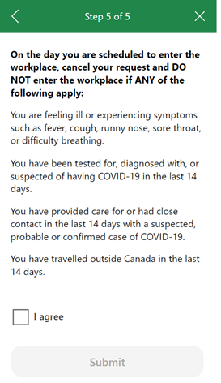

* **Your request has been submitted**: Once the request has been submitted, you will receive an email confirmation with your request details. Your DG will also receive an email notice saying that your request is ready for review.



* **Verify the status of your request**

Once your request has been submitted, you will be taken back to the “**My Requests”** screen where you can view the status of your requests. Use the “**Status**” drop-down to toggle between Pending, Approved, Declined, Cancelled, or Finished to view your selected requests.



24 hrs prior to you picking up your equipment you must complete the attestation for indicating that you will comply with the COVID-19 Health & Safety Measures.

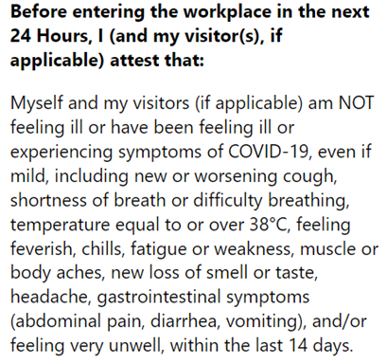

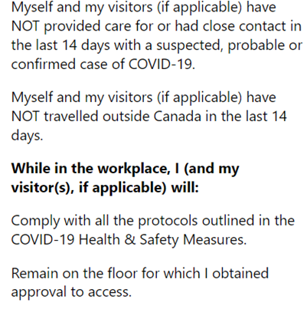

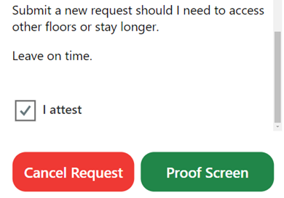

Once you attest to the above text a “Proof Screen” will appear. The Proof screen lists the building, floor, date, time, employee and equipment you will be picking up. Show this screen to security at the building.

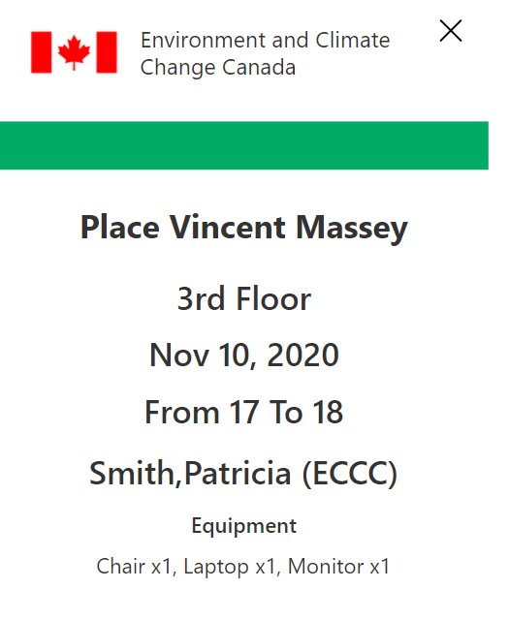

* **Cancel your request**

If you need to cancel your request, select it from the “**My Requests”** screen and click “**Cancel**.” Once your request is cancelled, it will appear under the “Cancelled” section of the “**My Requests”** screen.

 

# Approving a request to work on site

All employee requests are sent to the selected manager for approval. The manager will receive an email notification for each request, which will contain a link to view the request in the app. Managers can also log in to the app and view all pending requests for review. [A video is also available for this topic.](https://ecollab.ncr.int.ec.gc.ca/theme/media/_layouts/15/Lightbox.aspx?url=https%3A%2F%2Fecollab.ncr.int.ec.gc.ca%2Ftheme%2Fmedia%2FVideoLibrary%2FApproveRequest_HD.MP4)

Try It:

* From the **Home Page**, select “**Approve Requests”**.

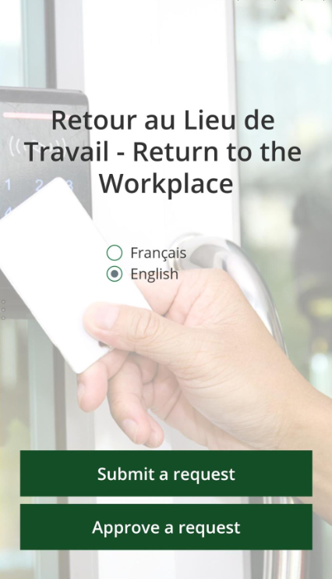

* The **Approve Requests** view will display all pending requests for the current week by default. Use the drop-down menu to toggle between Pending, Approved, Declined, Cancelled, and Finished requests. Click on a request in the list to review it.

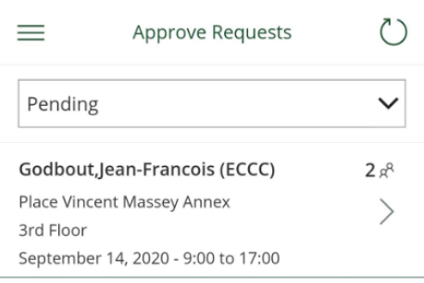

* **Review and approve/decline a request**
  + Once you’ve selected a request, you will be presented with the review page, which includes the requestor’s name, selected workplace area, timeslot, and reason. It also includes the total number of dates included in the request, as well as the total number of individuals (if there are any visitors accompanying the employee). Click on the “**Visitors**” button to view the details of any visitors included in the request. If multiple dates were added to the request, they will be listed here.
  + As the approver of the request, you can choose to approve or decline all of the dates within the request at once by clicking “**Approve/Decline All**” or to approve or decline each request separately. The employee who submitted the request will receive an email notification of your decision. You will be copied on the confirmation email.

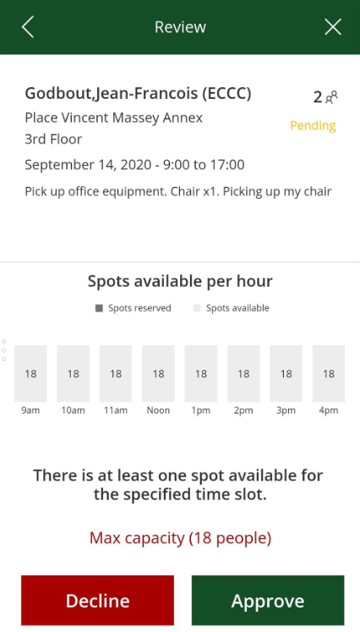

# Approving a request for picking up equipment

All employee requests are sent to the selected DG for approval. The DG will receive an email notification for each request which will contain a link to view the request in the app. DGs can also log in to the app and view all pending requests for review. [A video is also available for this topic.](https://ecollab.ncr.int.ec.gc.ca/theme/media/_layouts/15/Lightbox.aspx?url=https%3A%2F%2Fecollab.ncr.int.ec.gc.ca%2Ftheme%2Fmedia%2FVideoLibrary%2FApproveRequest_HD.MP4)

Try It:

* From the **Home Page**, select “**Approve Requests”**.



* The **Approve Requests** view will display all pending requests for the current week by default. Use the drop-down menu to toggle between Pending, Approved, Declined, Cancelled, and Finished requests. Click on a request in the list to review it.



* **Review and approve/decline a request**
  + Once you’ve selected a request, you will be presented with the review page, which includes the requestor’s name, selected workplace area, date, timeslot, and a list of what equipment will be picked up,.
  + As the approver of the request, you can choose to approve or decline the request by clicking “**Approve/Decline All**”. The employee who submitted the request will receive an email notification of your decision. You will be copied on the confirmation email.



# Booking Assistant

To accommodate users that require help submitting requests for any reason such as accessibility or technological issues there is a feature in the application called *Booking Assistant*. Employees who need help can give permission to another employee or their manager to book their reservation for them. [A video is also available for this topic](https://ecollab.ncr.int.ec.gc.ca/theme/media/_layouts/15/Lightbox.aspx?url=https%3A%2F%2Fecollab.ncr.int.ec.gc.ca%2Ftheme%2Fmedia%2FVideoLibrary%2FBookingAssistant_HD.MP4).

To do this the employee needing assistance or their manager needs to send an email to the [Service Desk](mailto:ec.servicedesk.ec@canada.ca) asking them to add “person x” as their booking assistant in the Return to the Workplace application giving the full name and @ec.gc.ca email address (**not** @canada.ca).

You will be notified when the booking assistant has been added. You can change the assistant when needed by emailing the [Service Desk](mailto:ec.servicedesk.ec@canada.ca) again asking them to update or remove your booking assistant.

## **Submitting requests as a booking assistant**

If you have been added as a booking assistant to help an employee reserve a spot to go into the worksite you will have a Change User icon on the top left corner of the home screen of your application.

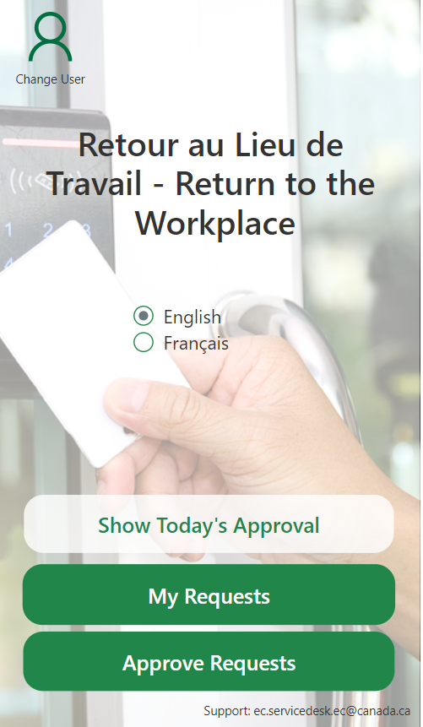

Click this icon and select the person’s name to submit a request on their behalf.

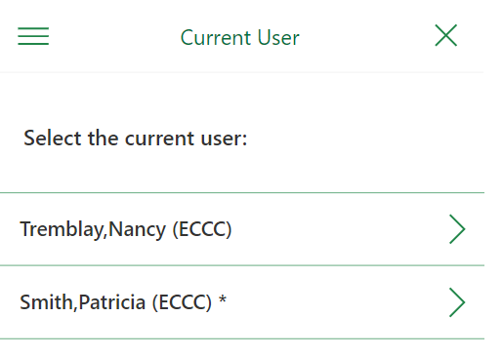

To return to your account, click Home on the main menu then click on the Change User icon again and select your name.

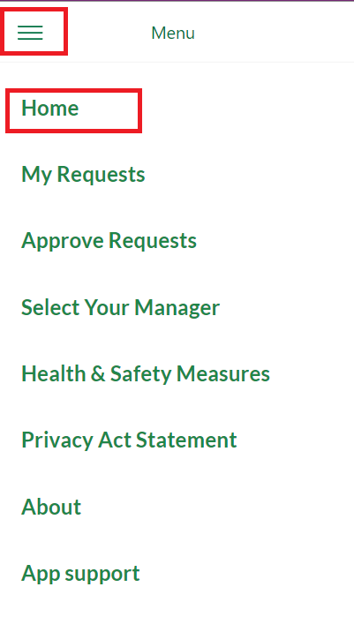

You can validate which account you are in by looking at the top right corner of the home screen where the name of the account you are logged in as will be displayed.

# Contact Us

If you have difficulty accessing the app or logging in to your Microsoft account, please contact the [Service Desk](mailto:ec.servicedesk.ec@canada.ca) for assistance.

If you have difficulty using the features of the app or have feedback, please contact the [Service Desk](mailto:ec.servicedesk.ec@canada.ca).

# Privacy Act Statement

The personal information is collected under the authority of the *Canada Labour Code,* Part II, the *Canada Occupational Health and Safety Regulations* and the *Financial Administration Act*.

The information is collected, used and disclosed for the purposes of monitoring workplace access and supporting a safe, healthy and gradual return to the workplace in relation to the COVID-19 pandemic. In the event of a suspected or confirmed case of COVID-19 in the workplace, the information provided through this app enables Environment and Climate Change Canada to conduct contact tracing while protecting the privacy of those involved.

Information on this application will be used, disclosed and retained in accordance with the conditions listed in the Personal Information Banks [Occupational Health and Safety PSE 907](https://www.canada.ca/en/treasury-board-secretariat/services/access-information-privacy/access-information/information-about-programs-information-holdings/standard-personal-information-banks.html#pse907) and  [Business Continuity Planning PSU 903](https://www.canada.ca/en/treasury-board-secretariat/services/access-information-privacy/access-information/information-about-programs-information-holdings/standard-personal-information-banks.html#psu903).

Any questions or comments regarding this privacy notice may be directed to Environment and Climate Change Canada's Access to Information and Privacy Division at ec.aiprp-atip.ec@canada.ca. If you are not satisfied that we have adequately respected your privacy, you have a right to file a complaint. You may contact the Office of the Privacy Commissioner of Canada by calling their information center at 1-800-282-1376 or by visiting their [contact page](https://www.priv.gc.ca/en/contact-the-opc/).

# COVID-19 Health & Safety Measures

Under the *Canada Labour Code*, employees have a duty to follow prescribed procedures with respect to the health and safety of employees, take all reasonable and necessary precautions to ensure the health and safety of themselves and others, and comply with all instructions from the employer concerning the health and safety of employees.

Throughout the COVID-19 pandemic, and until further notice, employees must comply with the following health and safety measures while at ECCC workplaces.

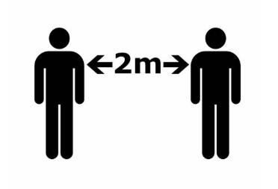

**Keep a distance of 2m from others**

* Adhere to Physical Distancing - maintain a distance of two (2) meters from others whenever possible. When it is not possible to consistently maintain a 2m distance from others, wearing a non-medical mask or face covering is recommended.
* Choose another workstation for the day if a workstation within 2m of yours is occupied. (N.B. This does not apply to enclosed offices or workstations with panel walls taller than 2m.)



**Use hand sanitizer before entering**

* Before entering the building or ECCC office area (for regional/DLSU offices), apply hand sanitizing solution, which will be made available.



**Comply with signage and occupancy limits**

* Comply with all directional indicators (corridors, stairwells, entrances, exits etc.).
* Comply with all maximum occupancy limits posted in applicable small spaces (i.e. elevators, meeting rooms, washrooms, kitchenettes etc.).
* Comply with all health and safety signage posted by relevant authorities (Government of Canada departments and agencies, property and facility managers, cleaning staff etc.).

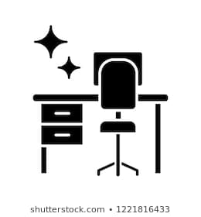

**Clean before and after use**

* Comply with the “Clean Before and After Principle” – Sanitize with provided wipes any surfaces and shared equipment before and after use (workstations, meeting room tables, countertops, photocopiers, shared office supplies, appliances etc.).
* Follow the “Clean Desk Principle” for any workstations used by removing all papers, supplies, personal belongings, and other items prior to departing the workplace to permit cleaning.
* Focus on using digital documents and avoid sharing paper documents.



**Maintain good preventive practices**

* Wash hands regularly for at least 20 seconds with soap and warm water, or use an authorized hand sanitizer, especially prior to eating or drinking and after touching high-touch surfaces (door handles, elevator buttons, shared supplies etc.).
* Use good cough and sneeze etiquette (e.g. sneeze and cough into your sleeve, not your hand).
* If you use a tissue, remember to dispose of it in a lined wastebasket as soon as possible and wash your hands afterwards. Where soap and water are not available, use an authorized hand sanitizer.
* Avoid close contact with people who are sick.
* Use alternative forms of greeting someone other than shaking hands (e.g. a head nod or a wave).

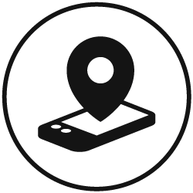

**Stay within approved area and time slot**

* Remain within the area(s) requested and approved through the workplace access request within the app.
* Submit a separate request through the app if access to additional floors is required, or if there is a need to stay longer than the duration of the initial approved request.
* Leave on time.



**Respect emergency protocols**

In the event of a building evacuation, follow building emergency protocols:

Employees are to put on their mask and exit the premises as quickly as possible using the nearest emergency exit/stairwell, even if physical distancing and directional indicators cannot be followed.

Once outside of the building, physical distancing is to be respected.

Employees who are unable to exit the building using emergency stairwells should self-identify to their manager (manager is responsible for OHS), the manager assigns 2 monitors to assist the person during an evacuation and the manager advises the Fire and Emergency Organization (FEO) through the floor emergency warden or the Chief/Deputy Chief of the FEO. Please refer to evacuation process for more details.



**Report COVID-19 symptoms**

* **If you develop symptoms before accessing the workplace:**
  + Cancel your request, do not access the workplace, contact your manager and public health authorities as needed.
* **If you develop symptoms while in the workplace:**
  + Isolate immediately within the workplace. Inform your manager immediately and escalate if necessary. Go home (avoid using public transit) and follow the advice of local public health authorities.
* **If you develop symptoms after leaving the workplace:**
  + Contact your manager if you experience symptoms within 14 days of leaving the workplace.

# Helpful links

* [Return to the Workplace - FAQ](https://ecollab.ncr.int.ec.gc.ca/org/11001/AutoDepanTI-HelpMeIT/Return%20to%20the%20Workplace%20FAQ.aspx)
* [Return to the Workplace - Guide](https://ecollab.ncr.int.ec.gc.ca/org/11001/AutoDepanTI-HelpMeIT/Return%20to%20the%20Workplace%20app.aspx)
* [Video demo](https://web.microsoftstream.com/video/2d0195f9-e4e7-4734-aab7-d626b23aaf4a)s
* [Mandatory Training](https://ecollab.ncr.int.ec.gc.ca/org/11001/Shared%20Documents/Training%20Strategy-EN.pdf)
  + COVID-19 Access to Worksite Mandatory Training and Awareness Session - for all employees

COVID-19 Access to Worksite Mandatory Training and Awareness Session – for supervisors and managers